Types and consensus 6

**1: Byzantine Fault Tolerance:**

Byzantine Fault Tolerance can tolerate up to 33% malicious nodes (1/3).

**2: Delegated Proof of Stack (**DPOS or decentralize proof of Stack)**:**

Its working is same like the general election ,to select the node from voting

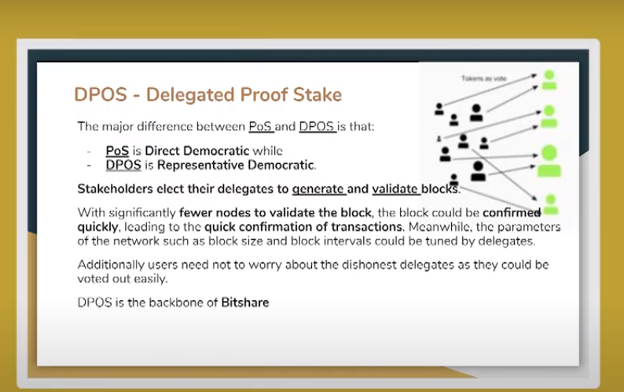

3:**RIPPLE:**

Ripple is the complete blockchain and also the consensus algorithm. Its 3rd most popular currency

Ripple consensus algorithm depends upon two type of nodes:

1. Server Node
2. Client Node

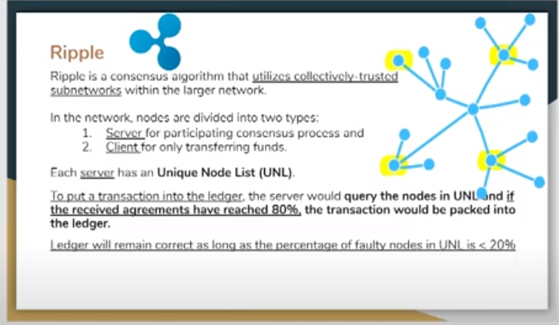

**4:Tendermint**(Byzantine Consensus algorithm)**:**

